Class – X Database Management System Sub- IT

Ch – 8 Introduction to Database Management System

D. Answer the following questions
1. Define the terms
Ans. (a) Database - A database is a collection of logically related data items stored in an organised manner.
(b) Data redundancy - Duplication of record is called data redundancy
(c) Report -A report is the formatted result of query which contain data required for decision making and analysis.

2. Give one point of difference between
(a) Data and Information,
(b) Form and Query,
(c) Network and hierarchical data model
Data | Information
Raw facts and figures is called data | Processed data is called information

Form | Query
A form is a feature of a database using which  we can enter data in a table in an easy and user  friendly manner. | A query is used to retrieve the desired information  from the database.

Network Data Model | Hierarchical Data Model
In Network Data model, multiple records are  linked to same master file | The Relational data model is based on the principle of  setting relationships between two or more tables of  the same database.

3. Give any four advantages of a DBMS.
Ans. Advantages of a DBMS are (Write any four)
1) Organised Storage : The data in the database is stored in an organised manner, so that retrieval of the required data is fast and accurate.
2) Data Analysis : A database helps in analysis of data based on certain criteria.
3) Reduces Data Redundancy : Database reduces data redundancy (duplication of data)
4) Sharing of Data : In a database, the users of the database can share the data among themselves.
5) Data Integrity : Data integrity means that the data is accurate and consistent in the database.
6) Data Security : Database provides data security as only authorized users are allowed to access the database and their identity are authenticated by using a username and password.
7) Privacy : The privacy rule in a database states that only the authorized users can access a database according to its privacy constraints.
8) Backup and Recovery : Database Management System automatically takes care of backup and recovery.

4. Consider the table given below and answer the questions that follow
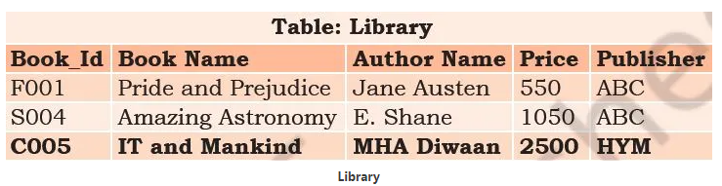
- Name the fields in the given table.
Ans. Fields in the table are
- Book_Id
- Book Name
- Author Name
- Price
- Publisher

- Which field should be made the primary key?
Ans. Book_Id
- Is there any alternate key in the table?
Ans. Book Name
- How is primary key different from foreign key? Explain with example.
- Ans.
Primary Key | Foreign Key
It is a field which uniquely identifies the records | The foreign key identifies a column or set  of columns in one (referencing) table that  refers to a column or set of columns in another (referenced) table.
It can not have NULL values | It can have NULL values

Ch -9 Starting with LibreOffice Base
D. Answer the given questions
1. Differentiate between:
(a) Memo and Varchar data type
Ans.
Memo | Varchar
It is used to store long alphanumeric data. for example Summary of a book, review of a movie etc. | It is used to store small alphanumeric data. for example Name, Address etc.
It can store text data up to 64,000 characters. | It can store text data up to 255 characters.

(b) Number and Decimal data type
Ans.
Number | Decimal
It is used to store integers of any length. | It is used to store decimal values.
for example 457, 342 | for example 23.56, 458.29

c) Design View and Datasheet view of a table
Ans.
Design View | Datasheet View
This view is used to design the structure of the table. | This view is used to enter the values in the table.
In this view, we can add or delete the fields | In this view, we can add or delete the rows

2. Name the menu items present on the Base User Interface
Ans. Menu items present on the Base User Interface are:
- File
- Edit
- View
- Insert
- Tools
- Window
- Help

3. Label the components – Title Bar, Database Pane, Tasks Pane, Status Bar of the LibreOffice Base User Interface.

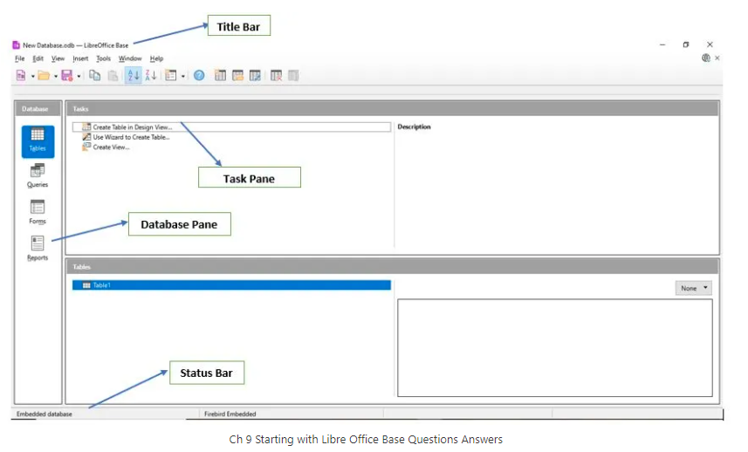
4. How can we define a primary key in a table?
Ans. A Primary key is a field which is unique for each and every record in a table. To make a particular field as the primary key, place the mouse pointer before the field name, and right click. A pop up menu appears and Select the Primary Key option. A key icon appears before the field name indicating that it is a primary key.
- Write steps to sort the table in descending order of primary key.
Ans. Steps to sort the table in descending order of primary key are:
- Open the table in datasheet view and select the primary key on which you want to sort.
- From the tool bar click Sort Descending icon to sort in descending order.
- The table will be sorted in descending order of primary key.

- What is the use of navigation box with respect to tables in a database?
Ans. Navigation box is used to navigate (move) through various records of the table.
The various components of Navigation Box are as follows:
Record Selector Box – This is the text box where the currently active record number is displayed. We may enter the record number that we want to see in this text box.
Navigation Buttons – These are used to scroll vertically in the table.
- Press |◄ button to move to the first record.
- Press ► and ◄ to move to the next and previous records respectively.
- Press ►| button to move to the last record.

